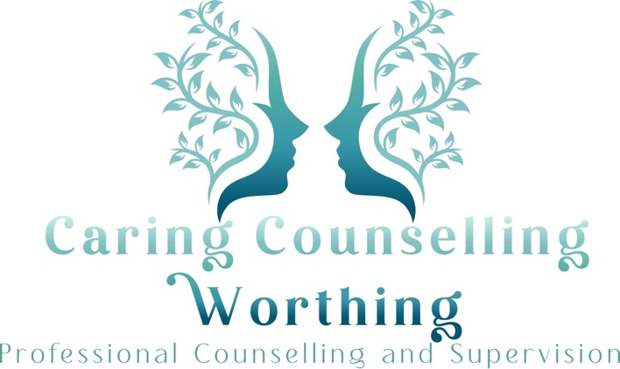

Residential Care Checklist: Questions to Ask Before Deciding

One of the most difficult moments in a caring journey comes when considering whether it would be better for the person you love to move into a residential care home.

It's a decision that can bring relief alongside profound grief (both of these feelings are valid), hope intertwined with loss, and a new kind of uncertainty even as it offers answers.

If you're weighing whether residential care might be necessary, consider these questions:

✓ Can your loved one make informed decisions about their care?
Notes

✓ Have they received all possible support to participate in decision-making?
Notes

✓ What other options have you explored? (homecare, sheltered housing, extra care housing)
Notes

✓ Could respite care help you feel more able to cope?
Notes

✓ Might short-term respite let you both try the environment before committing?
Notes

✓ What brings your loved one happiness, comfort, and safety?
Notes

✓ What would be the benefits for both of you?
Notes

✓ How might professional staff ensure better safety, comfort, and quality of life?
Notes

✓ If they move to residential care, how could you still be involved in their care?
Notes

✓ What impact would this have on your loved one?
Notes

✓ What impact would this have on you and others?
Notes

You don’t have to face everything at once — and you don’t have to face it alone.
For more information and support, visit:
https://caringcounsellingworthing.co.uk

